3D-Tag


General characteristics
- Objects materials: plastic, paper
- Dimensions: 50 х 50 ± 0,5 mm
- Antenna dimensions: 44 х 44 mm
- Pitch: 52,7 mm
- Standard: ISO 18000-63 / EPC global Gen2v2
- Operating frequency: 865 – 870 MHz
- Readrange: 10 m
- Operating temperature: - 20°С to +80°С
- Operating humidity: no more than 80 %

Electrical specifications
Memory | IC
Memory | NXP UCODE 8 | NXP UCODE 8m
EPC | 128 bits | 96 bits
Unique TID | 96 bits | 96 bits
Access Password | 32 bits | 32 bits
Kill Password | 32 bits | 32 bits
User memory | - | 32 bits

The structure of the tag

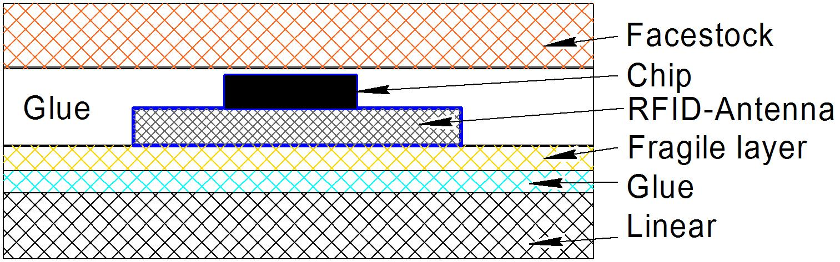

- Top material: PEFC RAFLACOAT PLUS

Delivery format
- Delivery format on the basis of self-adhesive
- Number of labels per roll: 2 000 pcs
- Inner roll diameter: 76 mm
- Outer roll diameter: not more than 200 mm
- MOQ: 1 roll

Directional diagram
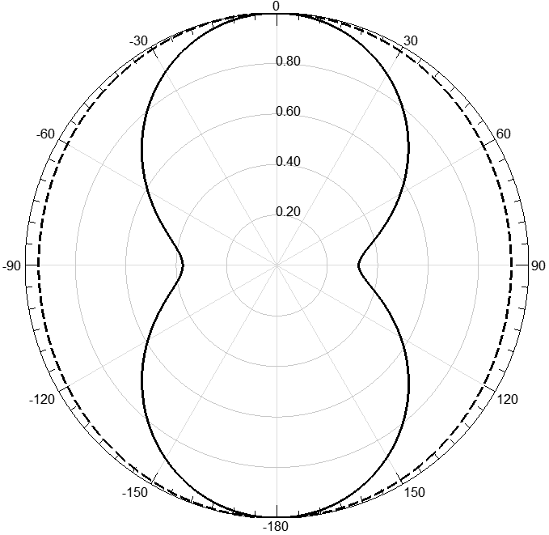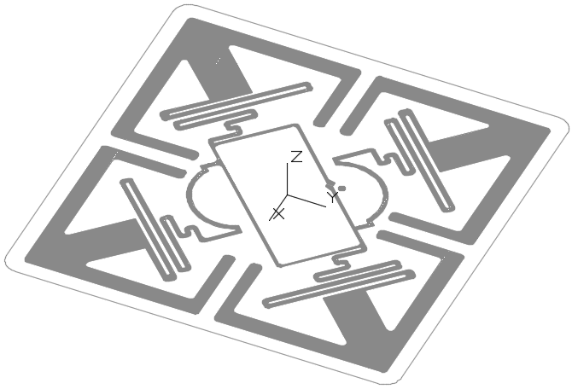
XZ-plane
YZ-plane
The normalized distance of the check, m

